**API Gateway and OpenAPI Spec**

* **OpenAPI Spec:** A common way to define REST APIs using a machine-readable format (YAML or JSON). It acts as an API definition as code.
* **API Gateway:** AWS service that helps manage and secure your APIs. It supports importing existing OpenAPI 3.0 specs to simplify API definition.

**Importing OpenAPI Spec to API Gateway**

An OpenAPI spec defines various aspects of your API:

* **Methods:** Actions available on your API (e.g., GET, POST, PUT, DELETE).
* **Method Request:** How the client makes the request (e.g., path, query string parameters, headers).
* **Integration Request:** How API Gateway forwards the request to your backend service.
* **Method Response:** How your API responds to the client (e.g., status code, response body format).

**API Gateway Extensions**

* OpenAPI allows vendor extensions using x- prefix. API Gateway utilizes these extensions for additional configurations beyond the base OpenAPI spec.
* You can set various options through these extensions, similar to what you would do in the API Gateway console.

**Exporting API as OpenAPI Spec**

* API Gateway allows exporting your existing API definition as an OpenAPI spec. This is useful for documentation or migrating to a different API management platform.

**OpenAPI and SDK Generation**

* OpenAPI specs can be used to automatically generate client libraries (SDKs) for various programming languages. This simplifies development by providing pre-built code to interact with your API.

**REST API Request Validation**

* API Gateway can validate incoming API requests before forwarding them to your backend. This helps catch errors early and avoid unnecessary calls to your backend service.
* Validation can check:
  + Presence of required parameters in URI, query string, and headers.
  + Structure of the request payload against a JSON Schema definition (specified in the OpenAPI spec).

**OpenAPI for Request Validation Setup**

* You can configure request validation by importing an OpenAPI definition file. This file defines the validation rules:
  + **Validators:** Define specific checks to perform on the request.
  + **params-only Validator:** Checks presence of required parameters only.
  + You can enable specific validators on individual methods (overrides inherited settings).

**Hands-on: Creating and Exporting an API with OpenAPI in API Gateway**

**1. Importing an Example API:**

1. Go to your API Gateway console and click "Create API".
2. Select "REST API" .
3. Click on "Example API". This defines a sample "Pet Store" API structure.
4. Click "Create API". You'll see a new API named "Pet Store" with pre-defined resources.

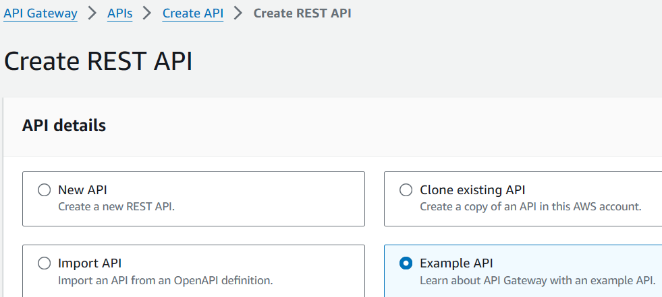

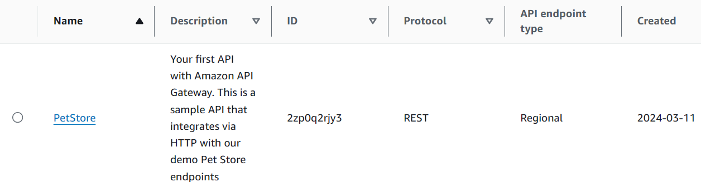

**2. Exporting Your Current API:**

1. Go to your existing API (e.g., MyFirstAPI).
2. Select a stage (e.g., prod).
3. Under "Stage Actions", click "Export API".
4. Choose the export format:
   * **Swagger or OpenAPI 3.0**
   * **JSON or YAML**
5. Optionally, enable extensions for:
   * **API Gateway**
   * **Postman**
6. Click "Export API". This generates a downloadable file containing your API definition.

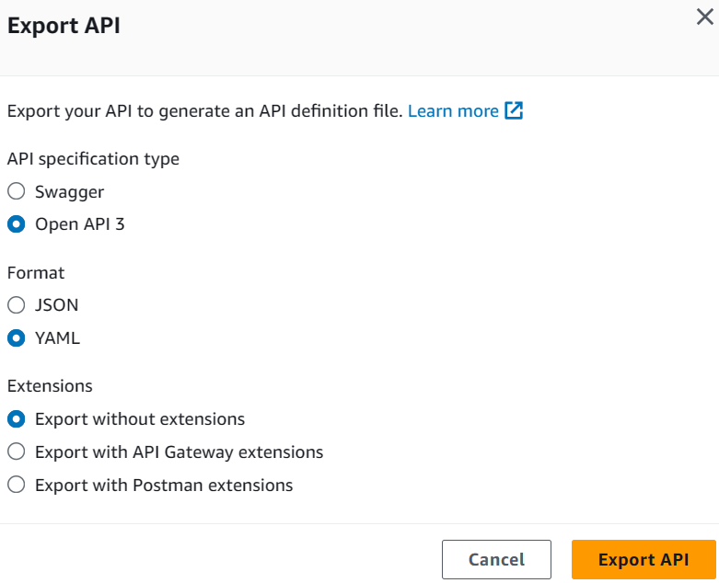

**Benefits of OpenAPI:**

* **Standardized API Definition:** Ensures clarity and shareability.
* **Automatic SDK Generation:** Simplifies client application development (Android, JavaScript, iOS, Java, Ruby, etc.).

